CIRCULAR-LINEAR ENERGY RECOVERY ACCELERATOR TO PROBE THE ENERGY-FRONTIER

I.V. Konoplev†1, JAI, Department of Physics, University of Oxford, Oxford, OX1 3RH, UK  
S.A. Bogacz, Jefferson Lab, Newport News, Virginia 23606, USA Ya. Shashkov, National Research Nuclear University MEPhI, Moscow, Russia   
1also at Sevastopol State University, Sevastopol, Russia

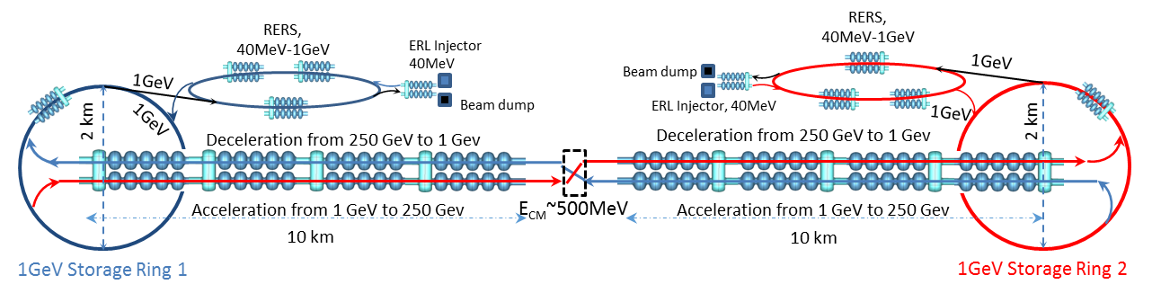Figure 1. Schematics of one of the possible configurations of the Circular-Linear Energy Recovery Collider showing the storage rings and recirculating energy recovery systems (RERS) located at each end of the linear collider.

Abstract

Energy-frontier particle accelerators are among the most exciting, complex, challenging, and expensive research instruments performing high precision measurements confirming the fundamentals of the physics and broadening new research horizons. Currently the highest energy machines (under design or commissioned), from multi-GeV to several TeV, (ILC, FCC, CLIC) capable of searching for the most basic building blocks of matter are either driven by circular or linear accelerators [1-6]. Here (see also [7,8]) we suggest a novel design of circular-linear accelerator based on the merging of the weakly emitting, low-energy storage rings and energy recovery linear accelerators. To enable the operation of such a system and in particular the energy recovery from spent, high-intensity beams the use of the dual-axis asymmetric cavities is suggested. Merging circular and linear systems, and applications of dual axes cavities, aims to resolve both scientific and societal challenges. The merge of the systems will allow:

1. maintain high beam quality, high luminosity, and high energy efficiency;
2. offer a “flexible” energy management via “separation” of the collider and storage rings operations;
3. attract private partners via use of the storage rings to drive the next generation of the photon factories.

The concept presented can be potentially used to reach ultimate energy frontiers in high-energy physics as well as to drive next generation light sources. We note that the numbers which will be presented are for illustration purpose and can be improved further.

Introduction

Most of the accepted state-of-the-art designs, while reaching the energies required, show the same signs of limitations scientific, technological, in attracting industrial partners as well as accepting flexible energy management [1-6]. One notes that the design of any such a complex machine is based on set of compromises, for example: at relatively low energies (sub-TeV), a circular machine has a better ratio of the power (MW) required to the luminosity generated, making them more attractive as compared with the linear machines, while at high energies (above TeV), there is no such advantage, and linear machines become more attractive. As a result, all the state-of-the-art designs are focused on scientific and technological challenges while addressing issues of societal acceptances and attracting industrial partners are often left outside the main scopes. Nevertheless, attracting industrial partners from the start and making energy management flexible, i.e. symbiotic with surrounding environment, will allow the natural and friendly merging of the machine into local community. In spite the obvious advantages even most recent suggestions [2-6] are not addressing these issues. In this work we discuss the concept (fig.1), which tries to take into account the possibility of attracting industrial partners via enabling for example EUV lithography and microchip quality assessment, pharmaceutical studies and novel material research, development and production [9-12], and simultaneously allowing efficient energy management of the whole complex. This can be achieved by introducing:

(a) “non-emitting” storage rings, between recirculating energy recovery system (RERS) and linear energy recovery collider (LER-C). Such “non-emitting” rings will be able to redistribute intermediate energy (1GeV) bunches between photon factories (FEL-stations) and LER-C;

(b) dual axis asymmetric cavities (fig.2) to assure the energy recovery of the high current (around 1A) spent electron beams [12-16] at all steps.

We note, that the concept (fig.1), which will be presented, is based on the systems, which has already been considered for construction (like ILC), commissioned (like CBETA) or demonstrated its capabilities (like MAX-IV).

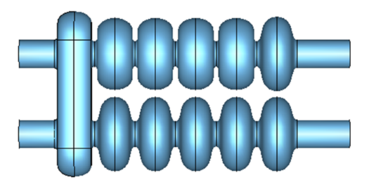

a2

a1

**(b)**

**(a)**

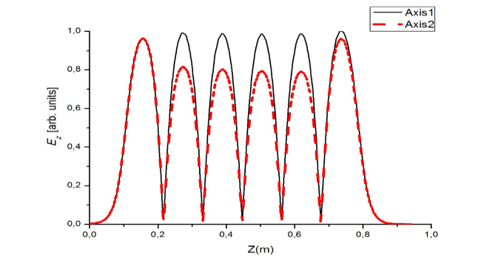

Figure 2. (a) The drawing of the dual-axis cavity with Tesla like cells and the Low-Loss + Tesla cavity cells along the bottom (Axis a1) and top (Axis a2) axes. (b) The operating mode structures along the axes showing the operating mode amplitude tunability by changing the cell’s geometry.

Preliminary concept of CLERC

To overcome the challenges discussed, we suggest Circular-Linear Energy Recovery Collider (CLER-C) to be based on dual-axis, asymmetric accelerating/decelerating (A/D) cavities. The schematic of the novel conceptual design is shown in figure 1, the arrows indicate the beam travel directions. All stages of the beam acceleration and deceleration (A/D) use the dual axis asymmetric cavities. This type of the cavity is suggested due to their EM properties [12-16], which would potentially allow one to increase the currents, at which BBU initiates, allowing the total beam power (current) to be increased. In the subsections below, the concepts of each sub-system will be discussed, starting with the dual-axis asymmetric cavity. The set of parameters presented in this paper are based on the possibility of merging the properties of circular and linear accelerators. We will discuss the use of “non-emitting” storage rings as drivers for photon factory (FEL stations) and CLER-C, broadening applications of the whole system and increasing its efficiency and societal impact.

*Dual axis SRF cavity*

For the clarity only, it is assumed that the cavities operate at 1.3 GHz. Figures 2a and 2b illustrate a possible design of the standing wave, dual-axis, asymmetric SRF cavity and field distribution inside respectively. Unlike conventional (single axis) systems, the dual axis cavity allows for the separation of the accelerating and decelerating beam trajectories. This mitigates the BBU instability excitations by breaking the feedback between parasitic HOMs excited in one of the sections and beam dynamics in other section. It has been demonstrated [14-16] that the HOMs excited in a specific section of the cavity are localised and will not impact the beam dynamics inside the other section. The most complex part of the structure is the bridge cell, and it has been recently constructed and tested at JLab [17,18]. Another advantage of such a cavity is capability to control the A/D fields’ amplitude independently. The operating field distributions are shown in Figures 2b and 3b, illustrating the possibility to vary the fields’ amplitudes in such structures by changing the cells geometries and a number of the cells. The independent field control allows the spent beams to be used in the ERL via increasing the decelerating buckets acceptance (field amplitude is increased fig.3b) allowing to compensate for energy spread, some electron beam current loss and the beam dephasing (from optimal decelerating phase).



**(b)**

**(a)**

Figure 3. Illustration of flexibility of the asymmetric SRF structure architecture showing the operating eigenmode accelerating field amplitude (a) contour plot, (b) dependence along the axes.

RECIRCULATING ENERGY RECOVER SYSTEM (RERS)

There are several advantages of use of Recirculating Energy Recovery Systems (RERS) as compared with a conventional ERL including the reduced number of the cryomodules (energy savings) and reduced footprint. In figure 4, the schematic of the RERS including: electron beam generation (40MeV), energy boost (from 40Mev to 1 GeV) and injection into the recirculating system is shown. The systems, similar to the RERS, are PERL and CBETA have recently been proposed and operation of CBETA has been demonstrated [19-21]. In RERS the beams would undergo four stages of acceleration in four full loops. A single loop has a three 1.3 GHz, 80 MeV SRF energy recovery capable modules, allowing the beam to gain/recover 240 MeV (Fig. 4), resulting in the 1 GeV/40 MeV beams respectively after the four loops. The linear non-scaling fixed field alternating gradient optics [19,21] can be used to transport the beams with the dual energies (in our case the energy factor below 2) along the one set of arcs while along the second set of arcs, the mono energetic beams will be transported. The spent beams are returned from RERS to the 40 MeV dual axis ERL to be decelerated and driven to the collector with energies below 1 MeV.

The bunch parameters are expected to be within the following limits: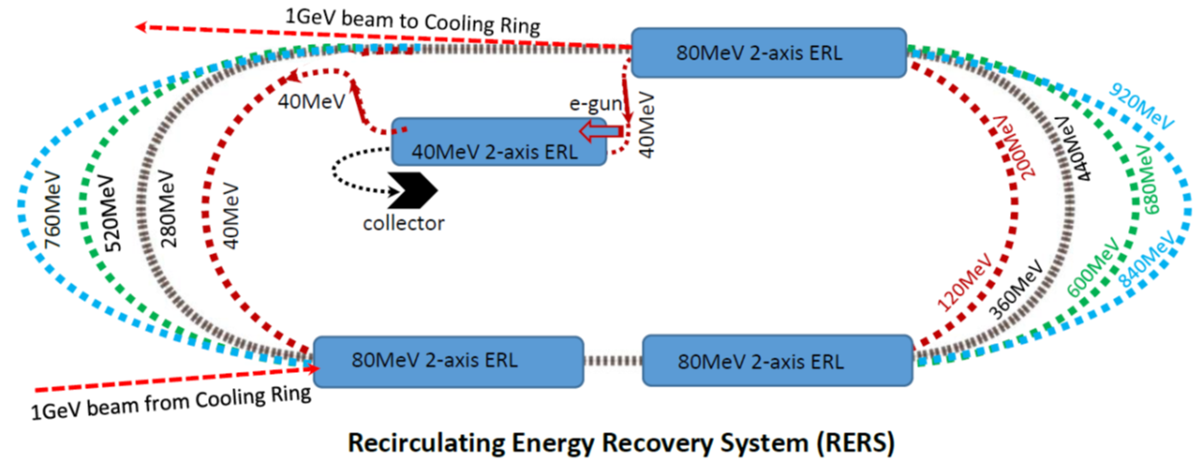 single bunch charge from 0.5 nC to 1.5 nC, repetition rate from 300 MHz to 700 MHz, RMS bunch length from 0.5 mm to 2 mm, transverse *rms* bunch dimensions, ${ σ}_{x,y}$, from 0.002 mm to 0.5 mm, average beam current from 0.1 A to 1 A. Before injecting the 1 GeV bunches into the cooling rings, they can be transported through a conditioning line (compression, cooling, etc.) to match the beam parameters to the beams inside the rings. In Table 1, the parameters of the RERS are presented.

Figure 4. Examples of the beam injection into storage ring systems Recirculating Energy Recovery system

Table 1: Example of possible RERS basic parameters as compared with PERLE and CBETA

|  |  |  |  |  |  |
| --- | --- | --- | --- | --- | --- |
|  | **RERS** | | **PERLE** | | **CBETA** |
| RF (GHz) | 1.3 | 0.801 | | 1.3 | | |
| Injection/Max energy (MeV) | 40/1000 | 5-10/1000 | | 6/150 | | |
| Rep.Rate (MHz) | CW | CW | | 325 | | |
| Beam current (mA) | 100-1000 | 10-20 | | 40 | | |

“NON-EMITTING” STORAGE RING

The Storage Rings (fig.5a) considered in this concept are multi-purpose systems. They are to be used for: collection/accumulation of bunches from the injectors (RERS), the collider (re-circulated beams) and photon factories(fig.5b); conditioning of the bunches; re-distribution of the bunches (i.e. re-injection for repeat applications), re-direction for dumping. All the beams prior to their use are accumulated in the storage rings (StRg), recirculated, and conditioned (if necessary). In Figure 1 the two large radius (1000 m), low energy (1 GeV) storage rings (red circles) are shown. An example of the storage ring, which has recently been designed and commissioned, and can be considered as a prototype is the MAX-IV system [22]. It is a 3 GeV machine with the 528 m circumference, having 20 folds seven bends achromat lattice. Using the MAX-IV parameters, as starting point, the storage rings for the CLER-C can be estimated considering the geometry scaling and the beam energy. One may expect that increasing the radius of the ring and decreasing the beam energy will improve the beam quality parameters, reduce the energy loss and ease some of the technical requirements. Thus minimise the emission of the synchrotron radiation from the bunches inside the ring, we suggest accumulating the bunches at a relatively low energy (1 GeV) while increasing the ring radius to 1km (6283m circumference). This would reduce the energy loss and beam quality degradation as synchrotron radiation generation scales as *γ4* and *ρ-2*. The choice of 1 GeV is also dictated by the compromise between SR energy loss and the ability to use such beams for the EUV photon generation without additional energy boosting and a schematic of EUV Free Electron Laser (FEL) with dual axis cavities is shown in figure 5b. It is assumed that under these conditions the rings will be unable to accumulate and maintain the beams for as long as required enabling the storage of up to 1 A of average current, with the expected energy loss due to synchrotron radiation not exceeding 0.1 keV per turn. The storage rings should also be used to condition the beams for a specific application and control the quality of the bunches. If electron bunches cannot be conditioned, they are moved to the collector via deceleration sections of the ERLs to be dumped with energies below 1 MeV, after passing through the ERL-injector. Using such storage rings allows to drive the photon factories to generate EUV, X-ray, and γ -photon radiation for research and industrial applications at FEL-stations as shown in Figure 5a. The design of the multifunctional Storage Ring will solve both scientific and industrial challenges [11], simultaneously broadening the research horizons of the project and attracting the industrial partners. Considering that the circumference of the ring suggested is 6.3 km, and assuming a typical undulator length of 150 m, one may expect a several (more than 20) FEL stations installed along the ring. Each FEL station (fig.5b) could have energy boosting and recovering systems, which would allow the generation of photons in a wide range of the energies. One may also position the FEL stations inside the ring (Fig. 5a) along the diameter, getting two contra-propagating beams of energies up to 10 GeV (each) and study, for example, Compton scattering of FEL photons on the 10 GeV electrons or γγ-collisions. The FEL-stations will maximise the efficiency, social impact and acceptance of the whole facility.



**(b)**

**(a)**



Figure 5. (a) Schematic of the intermediate energy (1 GeV), large (2 km) diameter, weekly radiating (below 1kW) storage ring indicating the FEL stations for photon production; (b) an example of the FEL station with dog-bone beam line for the beam energy recovery.

LINEAR ENERGY RECOVERY COLLIDER

To boost the beam energy, the beams are injected from the storage rings into the linear accelerators with energy recovery capabilities. The beams are accelerated from the initial energy 1 GeV, up to the required energy, *Wf,i*. After the interaction point, which is crossing point like ILC, and can be supported by similar optics as designed for the ILC, both beams are directed and transported through the decelerating arms of the dual-axis structures, reducing the beam energies to 1 GeV. Using the configuration described, the repetition rate of the bunches in LER-C is limited by the bunch repetition rate observed for non-emitting StRg. allowing to assume that the collider will be able to operate at high-repletion rate (like FCC). As the bunches will be injected into the rings by RERS (operating like PERLE in CW regime) one may also consider that in some configurations the collider will operate in CW regime as well.

To start, we suggest following the general system design chosen for ILC [1,4]. The collider’s left and right arms are 10 km long energy recovery linacs based on dual-axis asymmetric 1.3 GHz SRF cavities which operate at an average gradient of around 25 MV/m. Similar to ILC, a 4.5 km long beam delivery system can be used to bring the two beams into collision with a 14 mrad crossing angle, at a single interaction point. After the collision, the particles will undergo the deceleration to 1 GeV, and then re-injected into the storage ring for re-use. It is possible that further upgrades can be achieved by either increasing the accelerating gradient of accelerating structures, while maintaining the same length of the tunnel or increasing the length of the tunnel. An alternative of such “straight forward” approach is adding “dog-bone” arcs [23,24], as discussed in [6]. There are number of challenges in this case. Though, the idea of the using the arc in a dog-bone configuration, introduced for muon colliders in [24], is very fruitful, one remembers that the muon mass nearly 200 times larger as compared with an electron or positron. This means that for the same arc used for muon, the amount of the beam energy loss due to synchrotron radiation will be 1.6108 times larger. Using the expression for power loss $P_{SR}=0.089\left[\frac{MW}{turn}\right]\frac{E_{b}^{4}{(GeV)I}_{b}(A)}{eR(m)}$, one can estimate a single bunch of current, *Ib*, energy loss, noting that for LEP [25] at energy of 100 GeV, 6 mA (per bunch) and 3 km radius, the total power loss was around 20 MW or 3 GeV per turn. Taking this into account as well as loss of energy management flexibility, and possibility to install the FEL-stations the advantages of using the “dog-bone” configuration [6] is unclear as compared with the storage rings [8].

Considering the total power consumption from the grid, it is reasonable to assume that the main power loss in the system will be associated with the RF losses in the accelerating cavities. Assuming the number of the cavities to be around 15000 and development of novel cryogenic systems [26] it is possible to estimate that to dissipate 1W power from the SRF system one will need up to 1200W from the power grid. The table 2 illustrates the most important advantage of the novel system namely luminosity production efficiency i.e. *L0*×1034 cm-2s-1 per N(MW) from grid. The luminosity was calculated for the ideal “flat” beam, and it is assumed, that the beam of average current 0.5 Amp is accumulated in the storage ring (CW regime, 1.3 GHz) and every 10 sec bunch (to avoid beam-beam instabilities) is injected into the LER-C (10% duty cycle) for HEP experiments. In this case *L0* can be estimated ~ 50. In Table 2 the comparison of the luminosity efficiency (*LE*) for the ILC and CLER-C operating at 250MeV and 300MeV CoM energies at IP is shown.

Table 2: AC power (MW) consumption and luminosity efficiency for ILC and CLER-C (300GeV CoM, luminosity 50*1034 ).

|  |  |  |
| --- | --- | --- |
| **System** | **ILC** | **CLER-C** |
| Modulators | 58.1 MW | 6 MW |
| Cryogenics | 49.3 MW | 468 MW |
| Common infrastructure | 19.1 MW | 19.1 MW |
| *LE* | **0.0045** | **0.097** |

Conclusion

The machine presented is a lepton-lepton collider, capable of operating at the energy frontiers while being energy efficient and enabling flexible energy management.   
We discussed the challenges which conventional accelerators are facing, and alternative solution has been suggested. The concept of novel energy frontier accelerators has been presented and discussed. The design of the machine is based on merging of a several concepts, which have been recently developed and tested. It exploits energy recovery using dual-axis asymmetric SRF 1.3 GHz cavities, and due to using the non-emitting storage-ring the linear collider based on SRF dual axis cavities may operate either in high repetition or CW regimes (depending on specific design). The possibility to use the storage rings as photon factories to boost the research and societal impact of the project and to attract possible industrial partners is discussed. The enabling photon factories operating together with the collider will make the project more attractive for countries to host it as it may to help boost R&D in other areas like nano-electronics, biology, etc. and by inviting industrial partners, the total cost to the member-states can be smaller as compared with the similar cost for ILC.

**ACKNOWLEDGEMENT**

Prof I. V. Konoplev would like to thank STFC UKRI for partial support via grant (The John Adams Institute for Accelerator Science, ST/P002048/1), Sevastopol State University for partial support of the work via internal grant (42-01-09/169/2021-3). Work at Jefferson Lab has been supported by U.S. DOE under contracts DE-AC05-06OR23177 and DE-SC0012704.

**REFERENCES**

[1] V. Shiltsev, F. Zimmermann, “Modern and Future Colliders”, FERMILAB-PUB-19-481-AD-APC (2020) https://lss.fnal.gov/archive/2019/pub/fermilab-pub-19-481-ad-apc.pdf

[2] M. Benedikt, et al., “FCC-ee: the lepton collider”, Eur. Phys. J. Spec. Top. 228, p.261, (2019)*.*

[3] E.C. Aschenauer, et al., “eRHIC Design Study: An Electron-Ion Collider at BNL”, arXiv:1409 .1633, (2014)

[4] C. Adolphsen, et al., “The International Linear Collider Technical Design Report”, Volume 3.ii, Accelerator Baseline Design, (2013) <http://www.linearcollider.org/ILC/GDE/technical-design-documentation>

[5] V. N. Litvinenko, et al., “High-energy high-luminosity e+e−collider using energy-recovery linacs”, Physics Letters B 804, 135394 (2020)

[6] V. Telnov, “*A high-luminosity superconducting twin e+e-* *linear collider with energy recovery”*, Journal of Instrumentation 16, P12025 (2021)

[7] I.V. Konoplev, et al., “Novel Concept of Circular-Linear Energy Recovery Accelerator to Probe the Energy Frontier”, arXiv:2108.09111 [physics.acc-ph] (2021)

[8] I. V. Konoplev, et al., “Concept of circular-linear energy recovery accelerator to probe the energy frontier”, JINST 17, P01011 (2022)

[9] V. Cnudde et al., High-resolution x-ray computed tomography in geosciences: A review of the current technology and applications, Earth-Sci. Rev. 123, 1 (2013)

[10] I. Morichika, et al., “Molecular ground-state dissociation in the condensed phase employing plasmonic field enhancement of chirped mid-infrared pulses, Nature Comm. 10, 3893 (2019); doi:10.1038/s41467-019-11902-6.

[11] N. Nakamura, et al., “Challenges towards industrialization of the ERL-FEL light source for EUV lithography”, 10 IPAC (2019), JACoW Publishing, <https://accelconf.web.cern.ch/ipac2019/papers/thpmp013.pdf>

[12] I. V. Konoplev, et al., “Compact, energy efficient superconducting asymmetric ERL for ultrahigh fluxes of x-ray and THz”, AIP Conf. Proc. 1812, 100004 (2017).

[13] R. Ainsworth, at al., “Asymmetric superconducting rf structure”, PCT Application No. PCT/GB2015/053565 (2015).

[14] I. V. Konoplev, et al.,” Experimental studies of 7-cell dual axis asymmetric cavity for energy recovery linac”, Phys. Rev. AB 20, 103501 (2017)

[15] I.V. Konoplev, et al., “Ultimate energy recovery from spent relativistic electron beam in energy recovery linear accelerators”, Phys. Rev. AB, 23, 071601 (2020)

[16] R. Ainsworth, et al., “Asymmetric dual axis energy recovery linac for ultrahigh flux sources of coherent x-ray and THz radiation: Investigations towards its ultimate performance, Phys. Rev. AB 19, 083502 (2016).

[17] H. Park, et al., “Development of a superconducting twin axis cavity”, in Proceedings of LINAC2016, East Lansing, MI (2016), THPLR037, <https://doi.org/10.18429/JACoW-LINAC2016-THPLR037>

[18] S. U. De Silva,et al., “Electromagnetic design of a superconducting twin axis cavity”, in Proceedings of LINAC2016, East Lansing, MI (2016), MOPLR030, <https://doi.org/10.18429/JACoW-LINAC2016-MOPLR030>

[19] A. Bartnik, et al., “CBETA: First Multipass Superconducting Linear Accelerator with Energy Recovery”, Phys. Rev. Letters, 125, 044803 (2020)

[20] D. Angal-Kalininet al., “PERLE. Powerful energy recovery linac for experiments. Conceptual design report”, J. Phys. G45, 065003 (2018)

[21] W. Lou et al., “Beam breakup current limit in multiturn energy recovery linear accelerators”, Phys. Rev. AB, 22, 112801 (2019)

[22] P.F. Tavares et al., Commissioning and first-year operational results of the MAX IV 3 GeV ring, J. Synchrotron. Radiat., 25, 1291 (2018)

[23] S.A. Bogacz, Muon Acceleration Concepts for NuMAX: “Dual-use” Linac and “Dogbone” RLA, JINST, 13, P02002 (2018) [arXiv:1708.01274].

[24] J.S. Berg et al., Cost-effective design for a neutrino factory, Phys. Rev. AB, 9, 011001 (2006)

[25] D. Brandt, H. Burkhardt, M. Lamont, S. Myers and J. Wenninger, Accelerator physics at LEP, Rept. Prog. Phys., 63, 939 (2000)

[26] P. Lebrun, An Introduction to Cryogenics, CERN-AT-2007-001 (2007)

† corresponding author e-mail: ikonoplev202@gmail.com